VEX V5 Override: Session 1

Activity: Drive and try to score with Virtual Driving Skills Practice.

You will drive the Hero Bot, Flex, around a virtual version of the Override Field in Virtual Driving Skills Practice.
- The joysticks on the Controller drive Flex around the Field, based on the Drive Mode selected.
- The right and left sets of buttons control the Arm and Claw motors.
- Flex starts with a preloaded pin in its claw.
You score points by placing Pins into Cups, and parking in the Midfield at the end of the match.

Each Pin scored in a matching-colored Goal is worth 5 points.  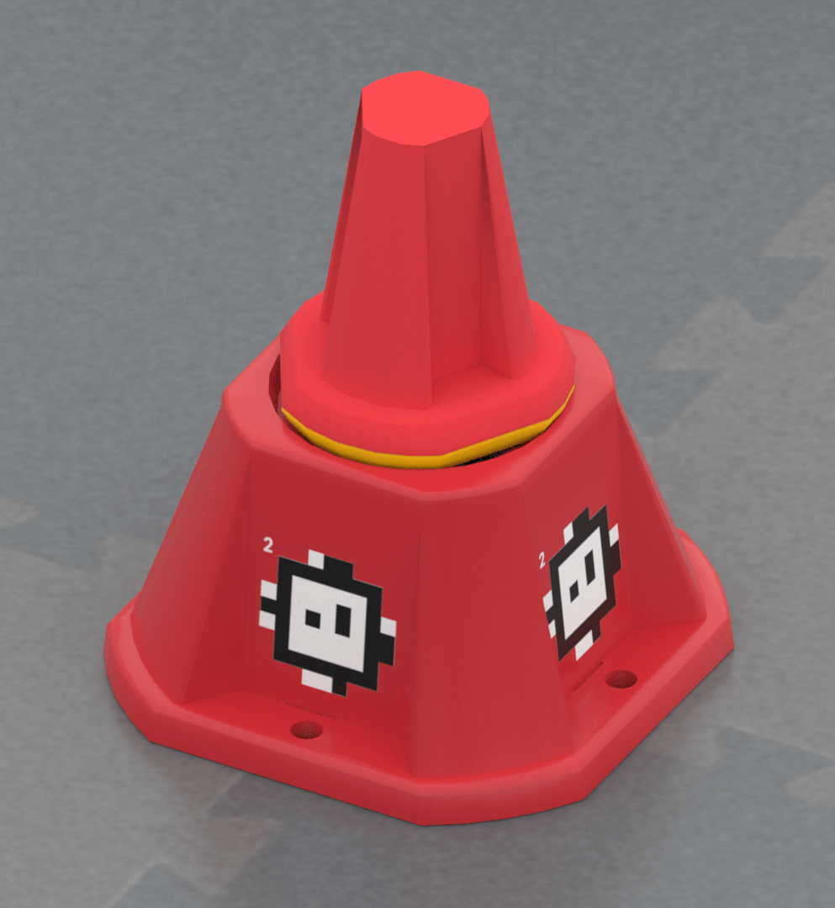 |  | Each owned and scored yellow Pin is worth 10 points. To own yellow Pins, set the Quadrant’s Toggle to your color.  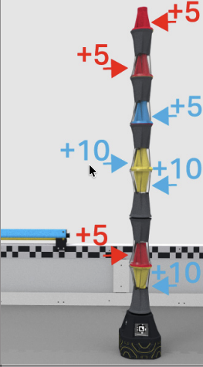 |  | A robot parked in the midfield at the end of the 60 second match is worth 8 points.  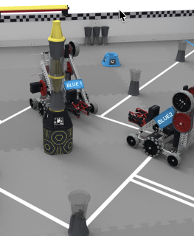

- Open VEX V5 Robotics Competition Override Virtual Driving Skills Practice.
  - You need your Team Number and Virtual Skills Key from your Coach in order to access the game.
- Choose one or more of the following to try when it is your turn to drive:
- Drive to a goal
- Score the preload in a Goal
- Place a Pin into a cup and score it in a Goal
- Intake a Pin or Cup from a Loader
- Turn the toggle to own the pins in a quadrant
- Park in the midfield at the end of the match
Remember, each team member will have at least one turn to drive.
Feeling Stuck?
Remember, the default Drive Mode is Dual (Tank) Drive. That means each motor is controlled by a joystick.

Discussion Questions
- Is driving Flex easier or harder than you thought it would be? Why?
- What is one pro-tip you would give to a teammate?
- What is one thing you want to practice more based on your turn?

